**Załącznik nr.1**

[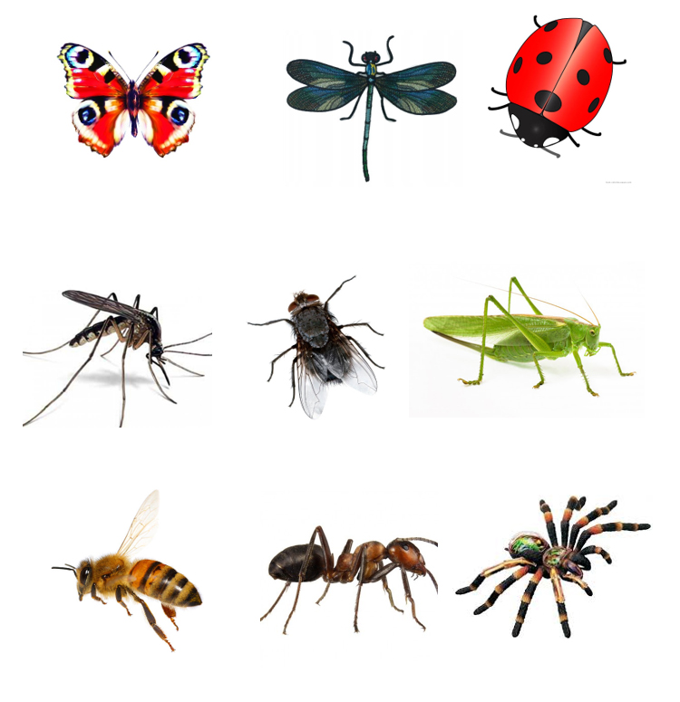](http://www.pp14.szczecin.pl/wp-content/uploads/2020/05/rys-11-05-5.jpg)